Patient Registration Instructions – myPatientVisit Portal
Step 1: Click on the link in the invitation email and/or text. If you did not receive the email, please check your “Junk” folder, or visit https://www.mypatientvisit.com/#/login?practiceID=WIMIKS

From the invite email/text it will automatically start to create your account. (Image 1).
From the link you will need to select create account. (Image 2)
(1)Invite email/Text (2) Link option
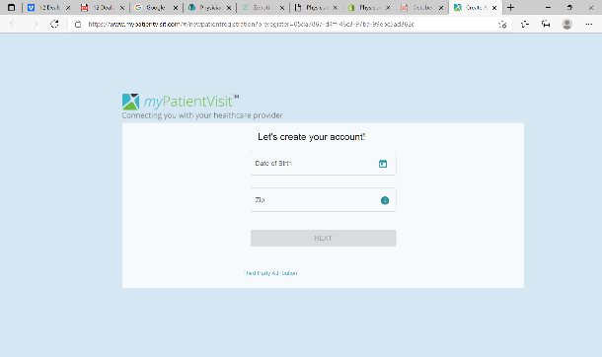
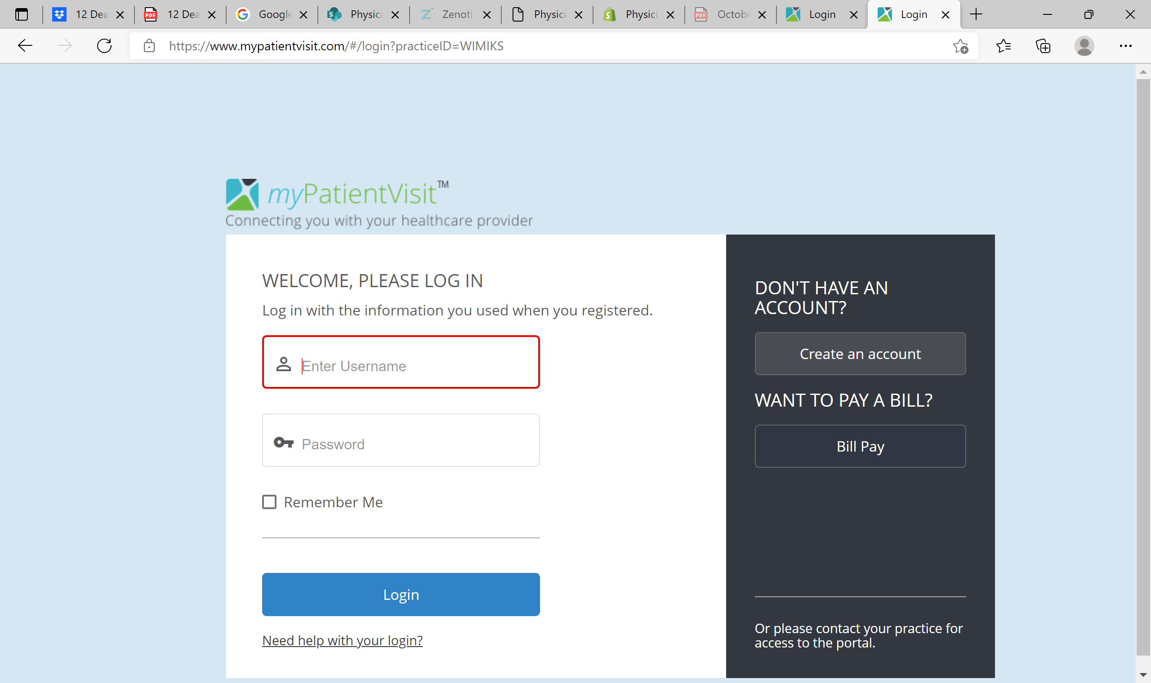

Step 2: Fill in all Sign-In information in the provided fields and create a unique password for your account.
*NOTE 1: First/Last name must match name on your patient record.
Step 3: Read the full “Terms & Conditions” and click the acceptance checkbox.
Step 4: Click “Register” and complete appropriate steps in the following section.
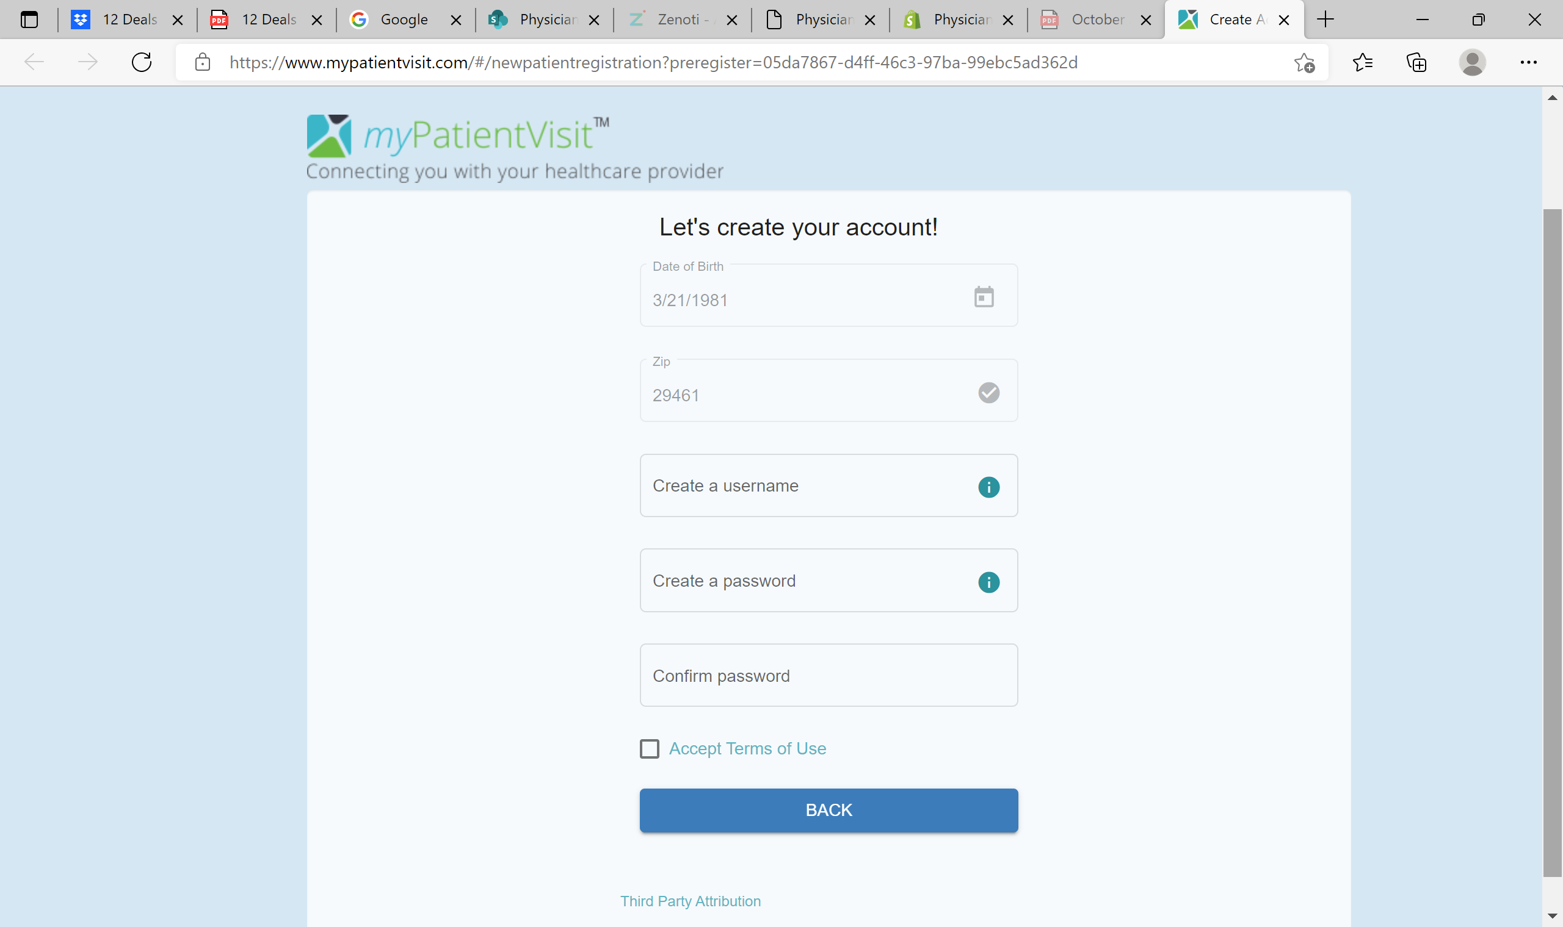

Select three Security Questions from the provided dropdown menus. Input appropriate answers and submit.
*NOTE: Security questions cannot be changed once submitted.
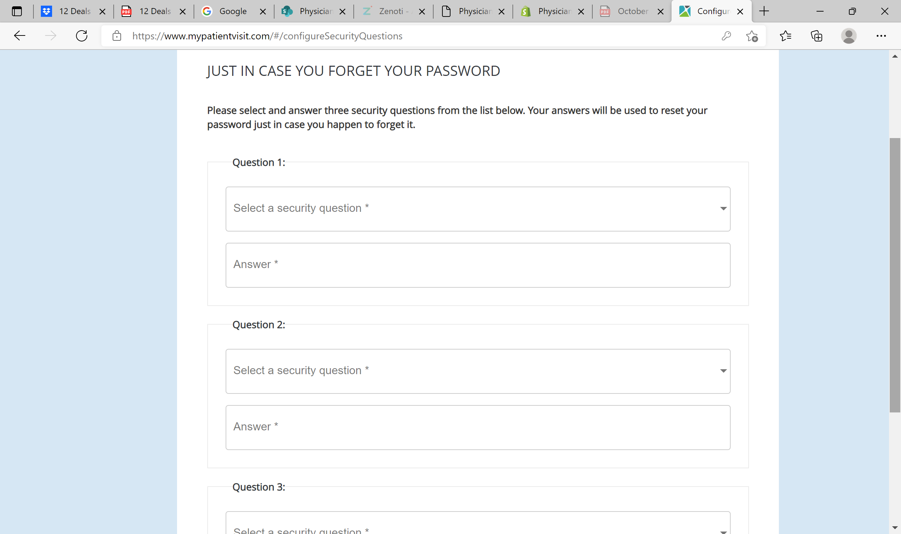

Step 5: Patient Dashboard will appear, giving you authorized access to portal tools.
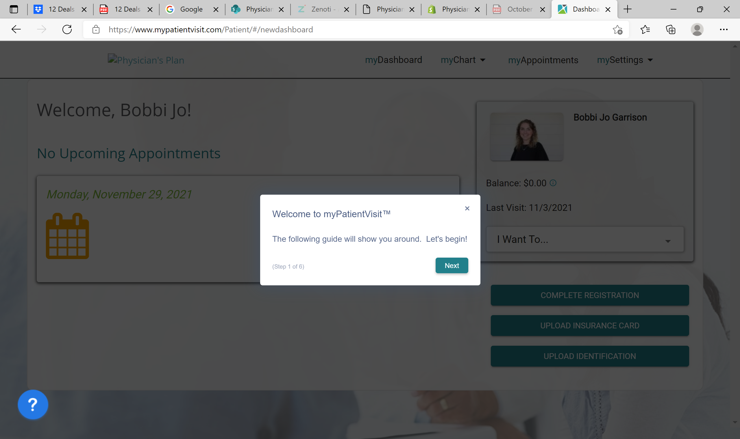

Step 6: Select “Complete Registration”
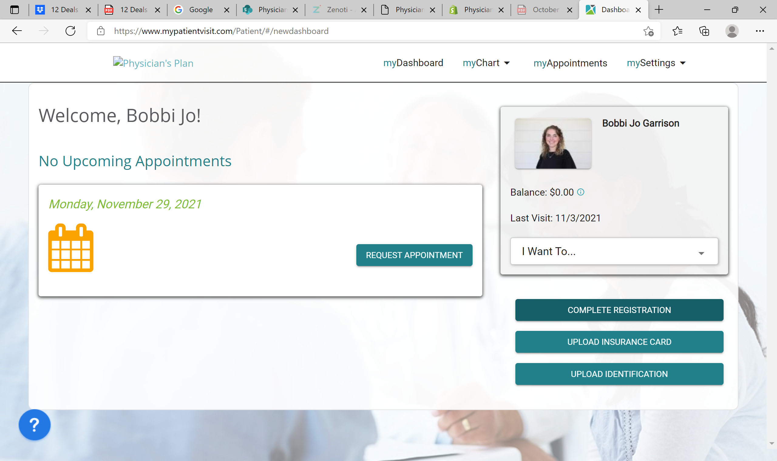

Step 7: Fill in your demographics and click next.

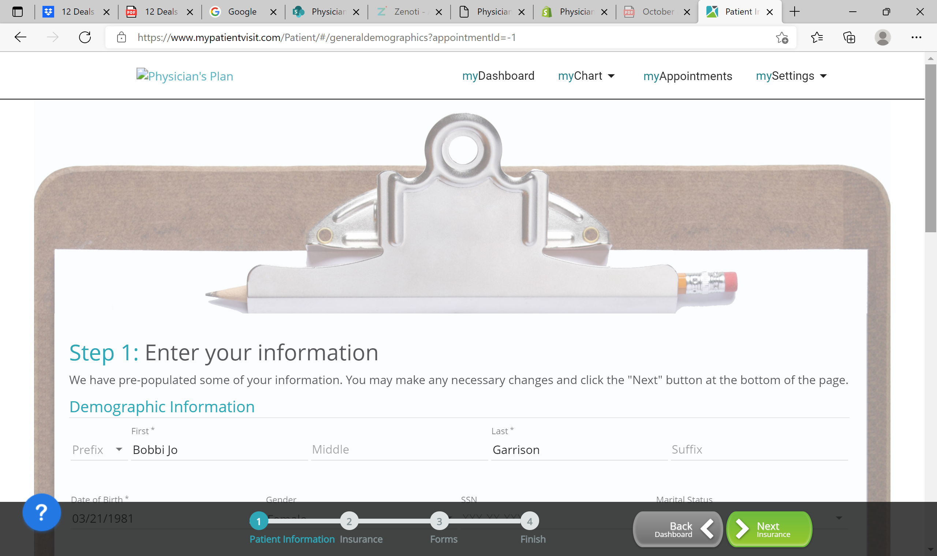

Step 8: Complete “Medical History” and “Online Forms”.
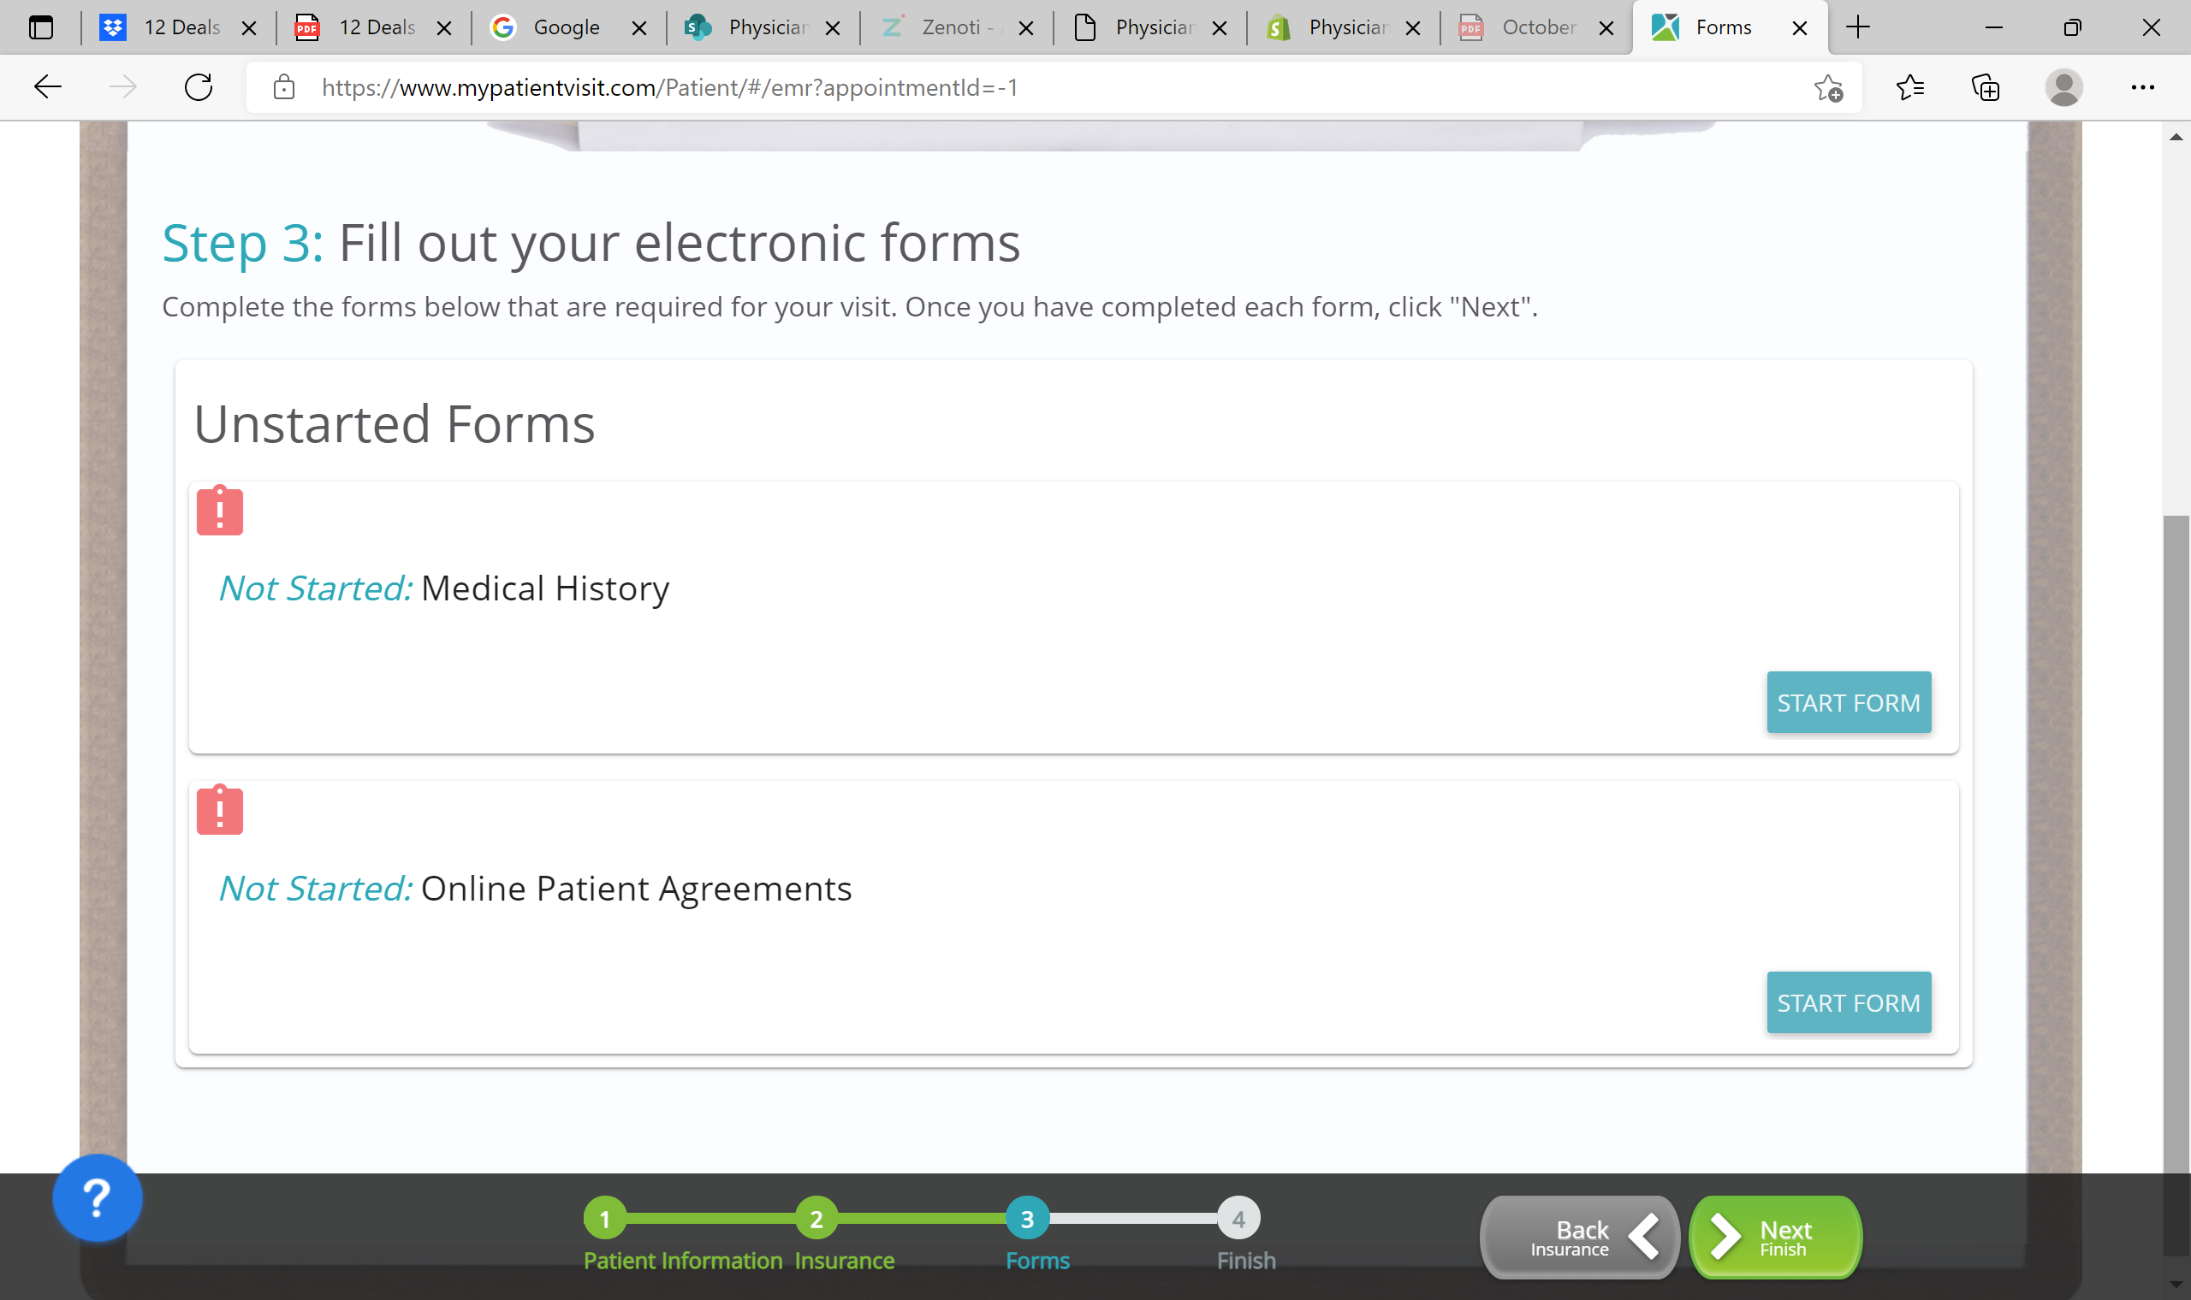
Once you have completed the forms you have completed your registration!
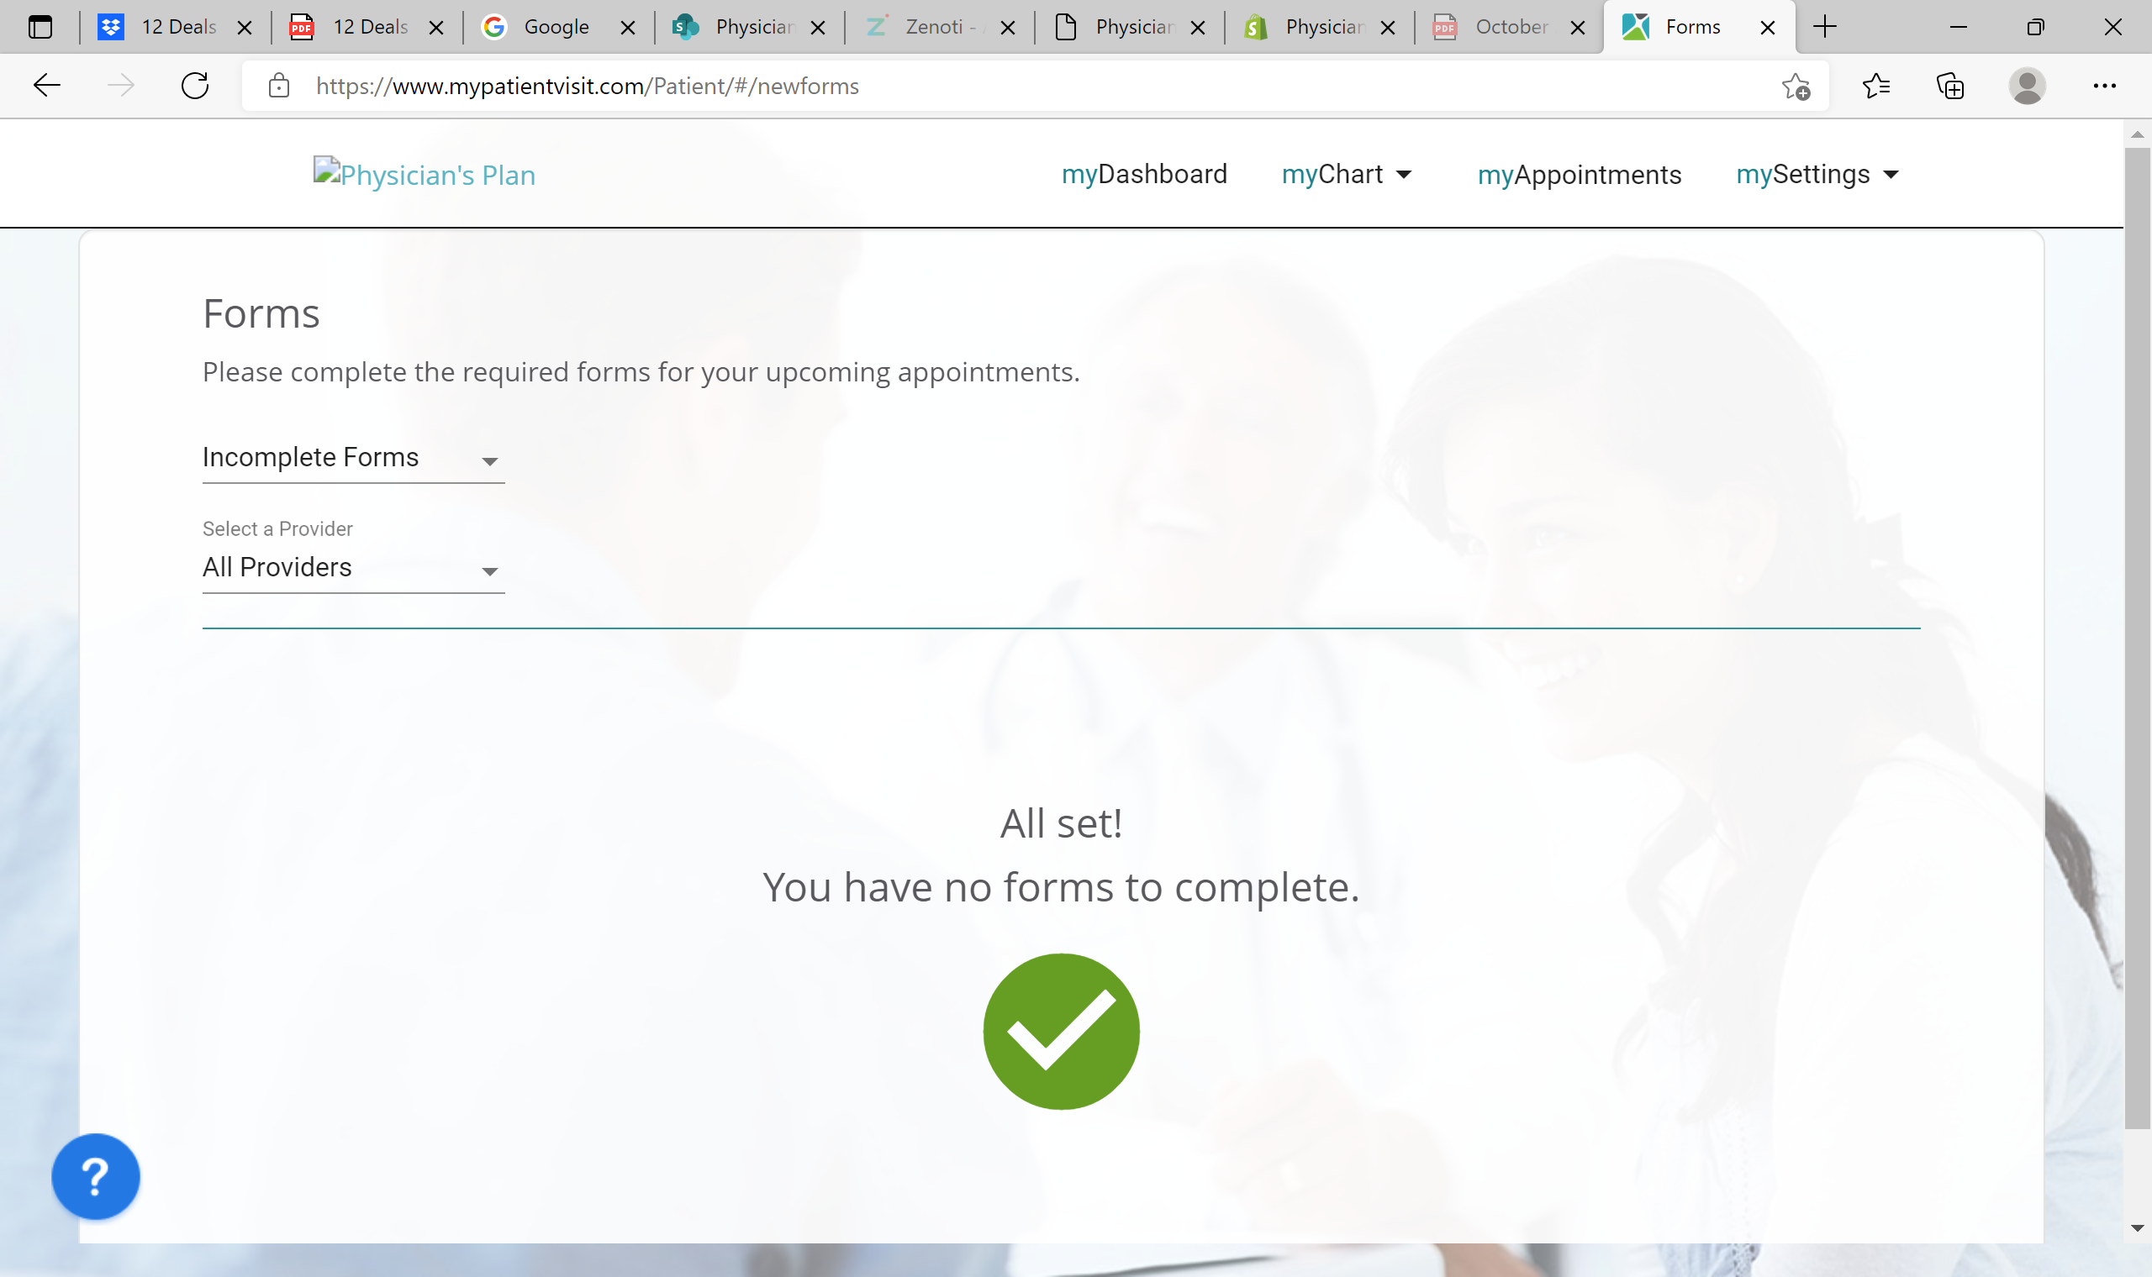

From your “MyDashboard” you can request and/or schedule appointments, see upcoming appointments, send and receive secure messages, and view documents. You can also download “mypatientVisit” app for quick and easy access.

